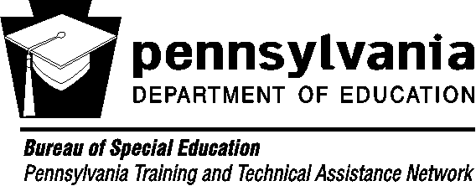
Financial Fundamentals: Discussion Starters

Six topics to help youth/young adults with disabilities and their families get a handle on their financial future
Money Management
Managing money includes setting goals and developing a plan for spending and saving.
You save money for future needs and wants. |  | Put it on Paper: Know Your Numbers  Income – Expenses = Cash Flow  Income (what comes in earned and unearned)  Expenses (what you spend)  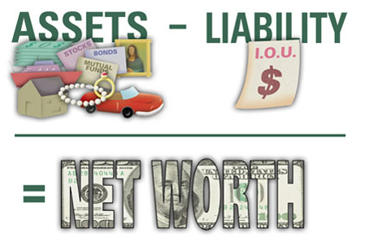  Assets – Debts = Net Worth  Assets (what you have)  Debts (what you owe)
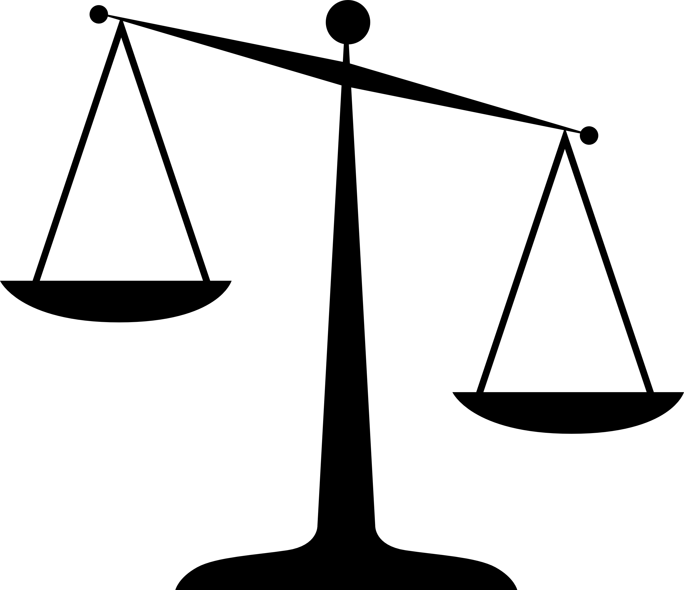  A need is something you must have to survive, like a place to live, food to eat, clothes to wear, and even healthcare! | A want is something you might like to have but don’t need to have in order to survive, like tickets to a concert, a new pair of shoes every week, or dinner out at a restaurant.
You should have financial goals, some short-term and some long-term.
A short-term financial goal could be saving enough money to buy a dress for a prom. A long-term goal could be saving enough money for a vacation.
Earning Money
Your ability to earn money is impacted by career planning, education, and job choices.
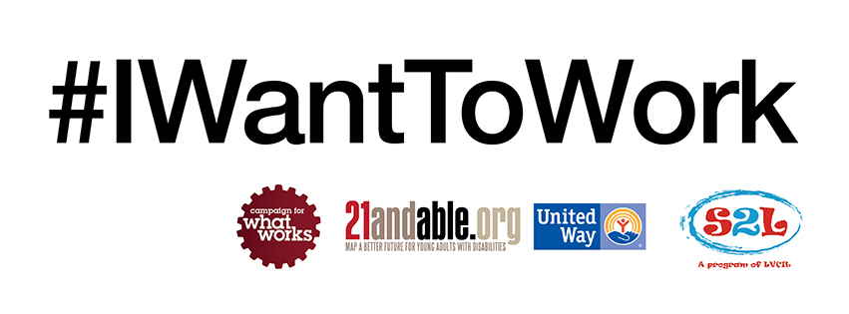  Work is good for everyone.  Everyone has something to contribute. The first step is figure out what your gifts are and what makes you happy. Those are the skills you should use to create your career.  If you are receiving government benefits, you should still try to find work because you’ll always do better financially when you combine your work and your benefits together.  There are limits to how much you can save and still receive government benefits. Make sure you know what limits are! |  | Did you know that the more you learn the more you earn?  Why is your paycheck less than what you thought?  Your take-home pay is always less than your wages because of taxes, health insurance premiums, retirement savings, etc. Knowing what comes out before you get your money is an important part of mapping your money.
Borrowing Money
Borrowing money has costs and benefits.
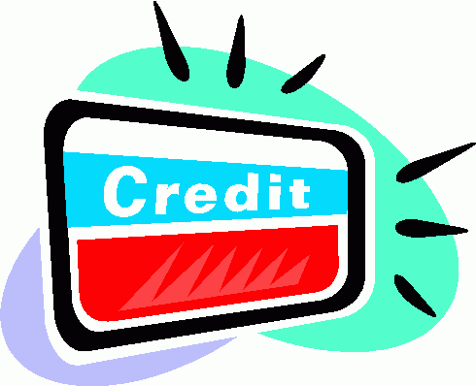  Credit allows you to borrow money when you don’t have cash but it’s not free. You can be charged interest and fees if you don’t repay the loan.  If you don’t pay on time or have too much debt, it will impact your credit and make it harder to do things like rent an apartment, have a cell phone or pay lower insurance rates.  Students can build good credit by being an authorized user on a parent’s account - so long as parents use credit wisely. |  | How can you find out if you have good credit? Order your free credit report online at www.annualcreditreport.com. Credit scores are available from a variety of sources - in some cases you may need to pay for it.  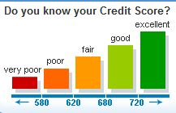

Financial Services
Banks, credit unions, and other financial institutions offer services to help you secure, access, and transfer your money.
Banks and credit unions are safe places to keep your money.  Whatever you choose, you should understand the following:  - What fees could you be charged for account maintenance?  - Is there a minimum amount of money you must have in your account?  - Does your account have overdraft protection to protect you if your balance goes below zero? If not, you may opt into this protection to avoid bouncing checks.  - How long after making a deposit is your money available?  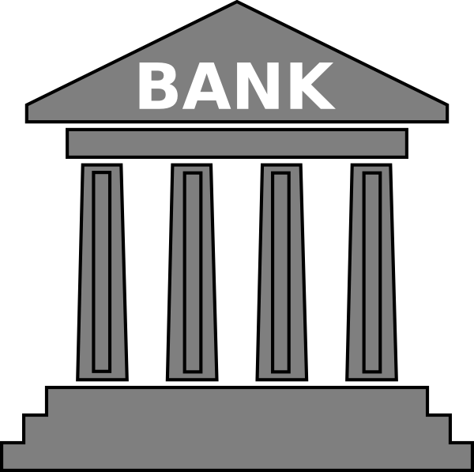 | Determine your financial needs:  - Do you need a checking account, savings account, or both?  - How could an ATM or debit card help you?  - Should you have a cosigner on your account?  - Does your employer offer/require direct deposit?  - Do you know how to balance a checkbook so that you always know how much money you have?  - Are there savings limits you need to be aware of in order to not lose Supplemental Security Income (SSI) benefits?  - Is a pre-paid debit card right for you? Be careful of the fees that could be involved.  - Do you know the dangers of using alternative financial services such as payday loans or auto title loans that can charge excessive interest rates?
Risk Management and Insurance
Risk management strategies are used to protect against potential loss.
Identity Theft: It can happen to you! Be smart about how you share your personal information and with whom.  - Ask questions before you share it  - Lock it up  - Shred it  - Password-protect it | How can you protect your finances from life’s unexpected events?  As hard as it may be, as a parent/guardian think about risk management. Write a letter of intent to provide guidance to give detailed care directions should something unexpected happen. Prepare a will and special needs trust. Make sure your child’s health insurance fits his/her needs.
Saving for the Future
Saving habits influence lifelong opportunities for financial independence.
Don’t be afraid to save! The new ABLE Act may allow you to save up to $14,000 a year and still be eligible for government benefits. Money in an ABLE account can be spent on technology, health care, housing, transportation, education, and many other things.  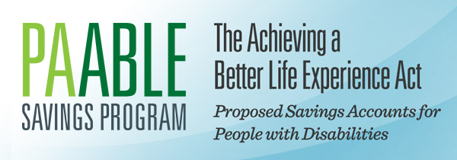  http://pa529.com/able.html | Family members can also save for your future. Money can be put into a special needs trust that can pay for things the government doesn’t such as travel, transportation, education, and entertainment. If the trust is created in the right way, the money in the trust will not affect your eligibility for government benefits. Advice from a lawyer is necessary to make sure the trust follows federal law.

Additional Resources for Financial Fundamentals

- Cents and Sensibility: A Guide to Money Management - Order a free copy of this guidebook by contacting the Pennsylvania Assistive Technology Foundation online at https://patf.us/contact-us or by calling: 888-744-1938

- Pennsylvania Secondary Transition Guide (www.secondarytransition.org) - The “Financial Fundamentals” section of this website provides information including state-specific resources related to finance, benefits, insurance, guardianship, wills and trusts.

